

Details | Who | Version & Date
Initial Release | Andy Brown | Draft A  18.02.2004
Updated | Tony Daniels | Release 1  03.01.2007

1st Generic Application Framework Architecture (FNET)

Table of Contents

Table of Contents 2
1. Introduction 4
1.1 Implementation 4
2. High Level Conceptual Design 5
2.1 Presentation Tier 5
2.1.1 Presentation Form Layer 5
2.1.2 Stateful Business Logic Layer 5
2.1.3 Communication Layer 6
2.2 Business Logic Tier 6
2.2.1 Web Services Layer 6
2.2.2 Stateless Business Logic Layer 6
2.3 Data Access Tier 6
2.3.1 Data Access Layer 6
2.3.2 Stored Procedure Layer 6
2.4 Communication Layer 6
2.5 System & Security Layer 7
2.6 Exception Handling Layer 7
3. The Presentation Tier 8
3.1 Presentation Form Layer 8
3.1.1 The Application Frame 8
3.1.2 Stateful Logic Layer 10
3.1.3 The Communication Layer 11
4. Business Logic Tier 13
4.1 Web Service 13
4.2 Stateless Business Logic Layer 13
5. Data Access Tier 15
5.1 The Data Access Layer 15
5.1.1 The Main Database 16
5.1.2 The Security Database 17
6. Shared Services 18
6.1 Communication 18
6.2 Exception Management 19
6.3 System Resources 20
6.4 Common Utilities 20
7. Physical Design 21
7.1 Solution Deployment Models 21
7.1.1 Stand Alone 21
7.1.2 Remote Database 21
7.1.3 Remote Business Tier 22
7.1.4 Mixed Architecture 22
8. External Services 24
8.1 Replication 24
8.2 Adviser Office 24
8.3 Third Party Systems using XML Messages 25
8.4 Third Party Products 25

Introduction
The generic application architecture was designed to support the following requirements.

- To support a variety of applications with a wide diversity of functions.

- To provide a consistent interface to the user and the supporting applications.

- To provide a scalable and tiered architecture that will run on a single machine for a single user or run on multiple machines with no change to the underlying code required.

- To provide a facility to allow the automatic updates via the internet to both code and data for the framework or any application.

- To provide a consistent security mechanism to control access and authority within the framework and any applications.

- To provide a consistent exception handling mechanism for reporting faults within the framework and any application.

- To provide licensing functionality for the framework and any applications.

This document aims to prove that these requirements have been satisfied by the design discussed in this document.

Implementation
The Framework architecture has been implemented using the following:

- Written using Microsoft’s .Net platform, with most of the code written in C# 2.0
- Favoured database being Microsoft SQL Server 2005 and/or SQL Express
- Favoured operating systems being Microsoft XP and/Or Server 2003

High Level Conceptual Design


Presentation Form Layer
Stateful Business Logic Layer
Presentation
Tier
Business Logic
Tier
Data Access
Tier
Stateless Business Logic Layer
Security
System Administration
Communication Libraries
Exception Handling
Data Access Layer
Database
Stored Procedures
Communication Layer
Web Services Layer

The separation of the tiers is orientated around enterprise clients who may wish certain business processes to be centralised on server farms.

Presentation Tier
The Presentation Tier is responsible for managing the user interface to the user. Typically it does not perform any business processing except for very basic common sense user input checks, such as optional and mandatory fields, negative ages etc.

Presentation Form Layer
This represents the user interaction component. This can be Windows Forms and/or Controls, Microsoft ASP.NET or any other technology that allows you to render or acquire data. This allows the interface to be modified without changing the underlying business logic.

Stateful Business Logic Layer
These are shared libraries that handle state management (state information is data about an entity such as a client or plan object and all associated properties such as surname, date of birth etc) and process flow between the presentation and business logic layers. This removes the need to hard-code any business logic in the user interface (apart from the simple rules such as date of birth later than today) and allows the same user interface "engine" to be reused by multiple user interfaces.

Communication Layer
Depending on the configuration, the Communication Layer determines where the Stateless Business Logic Layer is located (on the client or server) and routes all requests appropriately.

Business Logic Tier
The business logic tier is primarily responsible for processing requests from the presentation tier such as retrieving and saving client data It takes data in from the Stateful Business Logic Layer, performs the business process and returns a result. It contains all the rules necessary to perform the requests.

Web Services Layer
This is an abstract layer which enables processes to be exposed within a WAN (although it can be used within a LAN, this isn’t typical). If the business logic is situated in a location remote from the presentation tier, then this layer will be required to expose the business services.

Stateless Business Logic Layer
A business process may use one or more business objects. These business objects consist of common libraries and specialist objects. Any data access requests (reading and writing data) are passed to the business data access tier for processing.

Data Access Tier
This tier is responsible for controlling access to the database resources.

Data Access Layer
This layer aids, standardises and helps increase the performance communicating with the database. For example, when a stored procedure’s parameters are requested from the database, this layer will cache the results helping to prevent further unnecessary requests.

Stored Procedure Layer
Stored procedures are used to provide an abstract method of communicating with the database. It also centralises the data access making it easier to maintain.

The use of stored procedures mitigates the risk of SQL Injection attacks against the application from a publicly exposed presentation layer. Execute only privileges are available against stored procedures. The framework has no direct access to data. Stored procedures are also used to enhance system performance.

Communication Layer
The communication layer exists to help transport data to and from the client and server components.

Currently the communication layer supports two methods of communication for the near and far models.

- Near Model

The communication layer supports a “local” method of communication which assumes the presentation and business logic components exist side by side on the same machine.

- Far Model

The communication layer also supports a “Web Service” method of communication which assumes the presentation and business logic components are separate and web service calls are used to invoke the business logic layer.

This design would satisfy the requirement for operating an n-Tier solution:

- To provide a scalable, n-Tier architecture that will run on a single machine for a single user or run on multiple machines with no change to the underlying code required

System & Security Layer
This layer controls access to and authority within the application. This includes authentication to the application and the database. User authentication is done using Windows authentication. This supports Active Directory.

When the user is authenticated (using Windows authentication), this application sets appropriate access controls within the system (forms, controls and fields).

Access to the database is handled using a single user account setup during installation. The user does not have direct access to the database, so they are unable to access the data using tools such as MS Access.

All passwords and connection strings are encrypted.

Exception Handling Layer
This layer performs standardised exception handling within the architecture. For information please see the chapter on shared services.

The Presentation Tier
Presentation Form Layer
Stateful Logic Layer
Communication Layer

Presentation Form Layer

The Application Frame
The application frame is the main executable used for running a specific version of the presentation tier.

Requirement: To support a variety of applications with a wide diversity of functions

The Generic Application Framework provides an Application Frame component which hosts suitable assemblies to provide the user interface functionality. The assemblies can be considered as plug-ins, but are referred to as Applications through the rest of this document.

The application frame has been built to host one or more suitable applications. The components of the application frame (see Figure 3.1a) are configured either by the security context (see the security chapter) of the user, or by the supported interfaces on the loaded application and its own context.

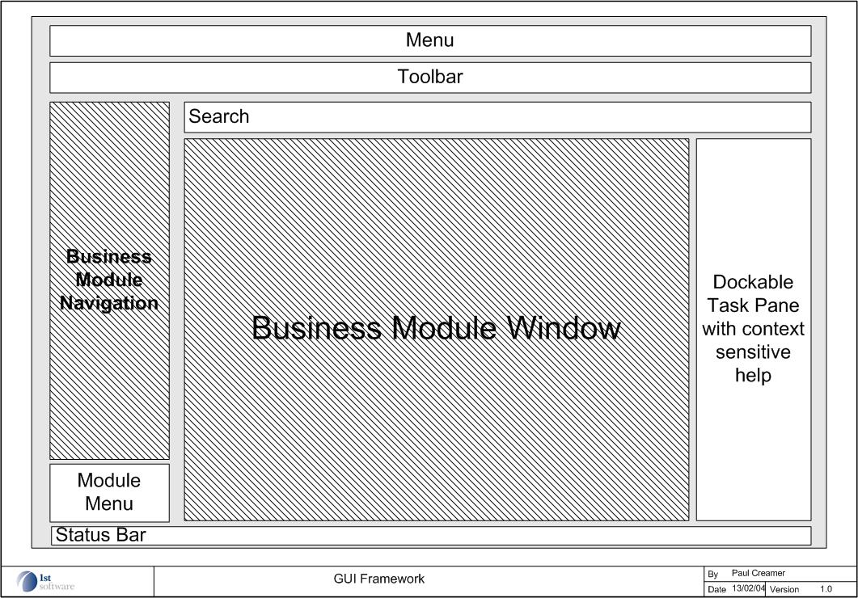

Figure 3.1a – The Application Frame Components

Each application will contain several forms; inspectors; dialog boxes etc. which can interact with a user and this can be show conceptually in figure 3.1c. An example of a populated application frame using Mortgage Adviser is shown below:

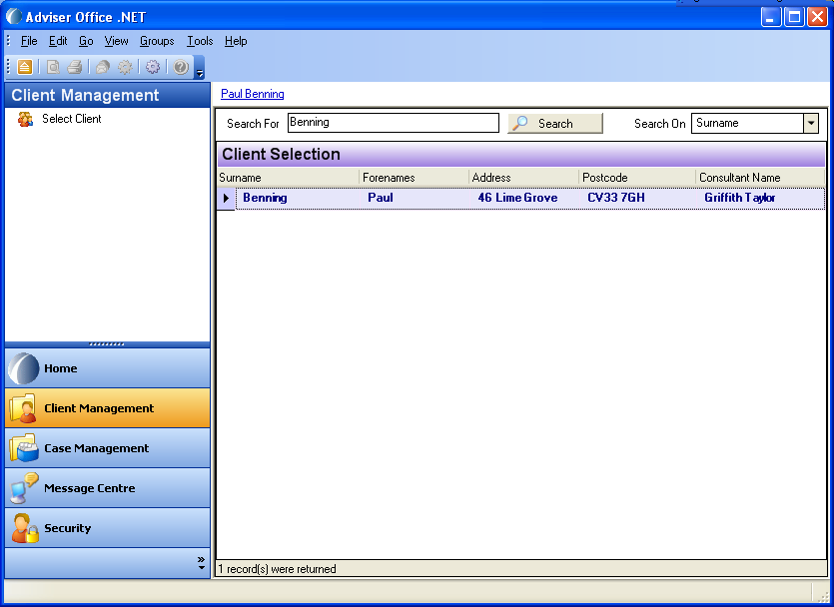

Figure 3.1b – The Application Frame – Mortgage Adviser

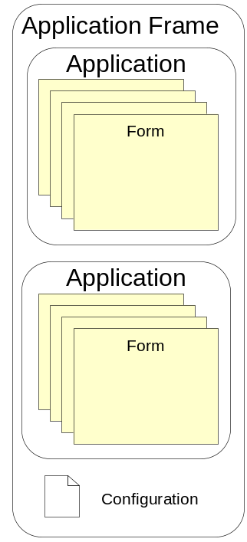

Figure 3.1c – The Application Frame Model

The application frame supports a configuration file. This file will hold necessary information for the application frame such as:

- Minimum database versions
- Communication model to use and
- Encrypted database information
- Exception Management Information

Each application itself will be made up of forms inherited from a supplied base forms class. Each form will be made up of controls, themselves supplied by a base controls class. The controls supplied are intelligent enough to consider caching information such as security/access contexts and drop down code lists to help prevent unnecessary network traffic and database loading.
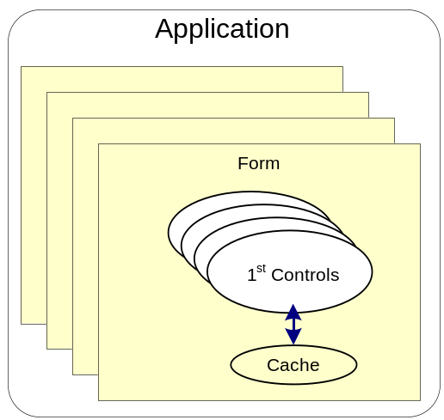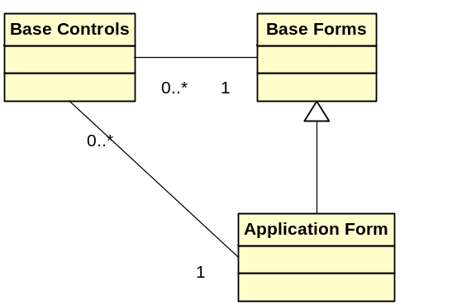

Figure 3.1d – The Application Model

In the diagram above we can see that applications contain forms, and these forms will be based on a framework base forms class. Each one of these forms will also be able to host controls which will also be based on a frame work class.

Stateful Logic Layer
Applications can make use of local components to handle information about entities and manage state. This is the Stateful logic layer also controls communication from the presentation layer to the business logic layer. Therefore the layer performs the following functions:

- Manages States across objects that have been created by the loaded Application

- Manages Data for the associated objects

- Manages any caching required for repeated requests for information

The Stateful logic layer can usually be split into two general components for any given application.

- The Core Stateful Logic which contains the common logic that will be required across all applications and be used by the application frame (i.e. for user and security authentication).

- The Custom Stateful Logic which can potentially be unique to the single application that is being used. For example, a method to retrieve information on a fact find completed for a client.

The diagram below shows two applications and how they could possibly interact with the stateful layer.
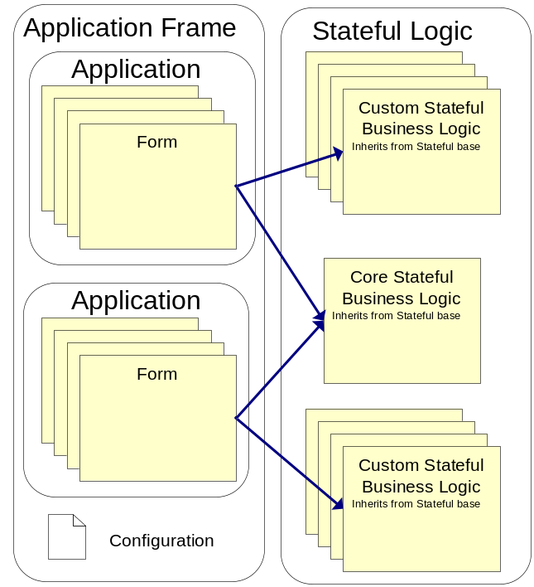

Figure 3.1e – The Stateful Logic Model

The Communication Layer
The final part of the presentation tier is the communication layer. This layer handles communication between the presentation tier and the business logic tier.

The application frame offers the option to configure the presentation layer communication properties. Currently two options are offered, Local, and Web Service. If local is selected then the business logic components are assumed to be local on the same machine as the presentation layer. If Web Service is selected, then they are assumed to be on a remote web server, and the user is prompter to provide the correct URL.

Depending on what is present in these settings, the communication layer directs requests accordingly.

In the diagram below we have assumed that all requests have been routed to the local machine as the business logic tier resides on the same machine.

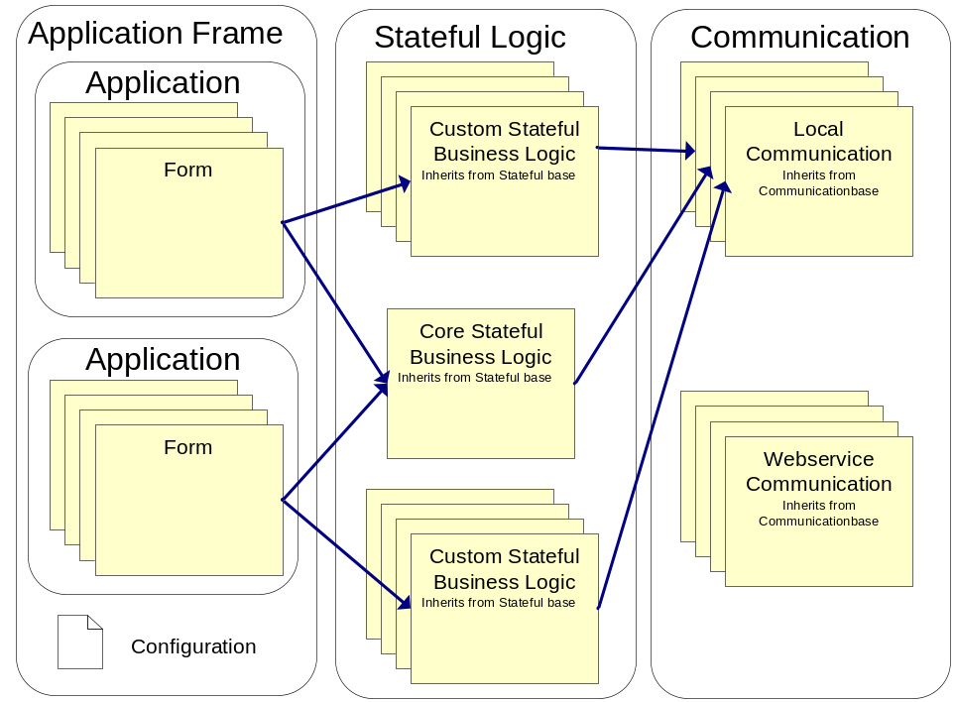

Figure 3.1f – The Complete Presentation Tier Model

More information on how this is achieved can be found in the shared services chapter as this discusses communication between the presentation and business logic tiers using the shared components.

Business Logic Tier
Stateless Business Logic Layer
Web Service

Web Service
If the business logic components are situated remotely from the presentation layer, then remote requests for information and services will be routed through a web service.

The web service call will be an abstraction of the local call to the stateless business object layer. If a web service is used it will gather relevant information from a configuration file in the same way the application frame gathers information from a configuration file. This file will hold exactly the same information allowing the web service to route the call to the correct database.

The web service will expose the same service interfaces as the stateless business logic layer. More information on how this is achieved can be found in the shared services chapter as this discusses communication between the presentation and business logic tiers.

The web service routing is defined in the application frame configuration file under the communication options. It can be controlled form the Application frame Tools/Options dialog. The communication mode must be set to web service to invoke the “Far” method of operation, and then the URL of the web service must be entered.

If a proxy server is being used for shared internet access, and no proxy-client software is being run on the client machine, then these details must be pre-configured in the dialog in order for the web service calls to be successful.

Stateless Business Logic Layer
This layer handles request from clients, processes them and returns any information or exception information to the calling client without maintaining any state.

The stateless layer invokes the data access layer to perform operations on the database. There are several different types of operation that occur and usually a typed dataset is used to pass and retrieve data from the database. For example, if a request for client data is received, the stateless business logic will make a request to the Data Access Tier for the client information and return it as a typed dataset.

More information on how this is achieved can be found in the shared services chapter as this discusses communication between the presentation and business logic tiers.

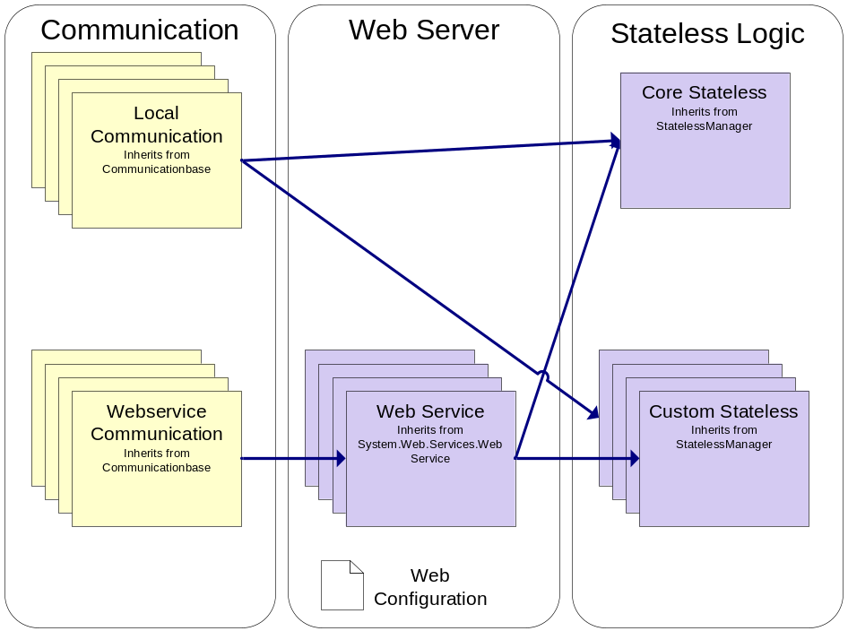

Figure 4.1a – The Business Logic Tier Model

Data Access Tier
Data Access Layer

Data Access Layer

Stored Procedures

The Data Access Layer
The data access layer centralises all request for data from the databases.

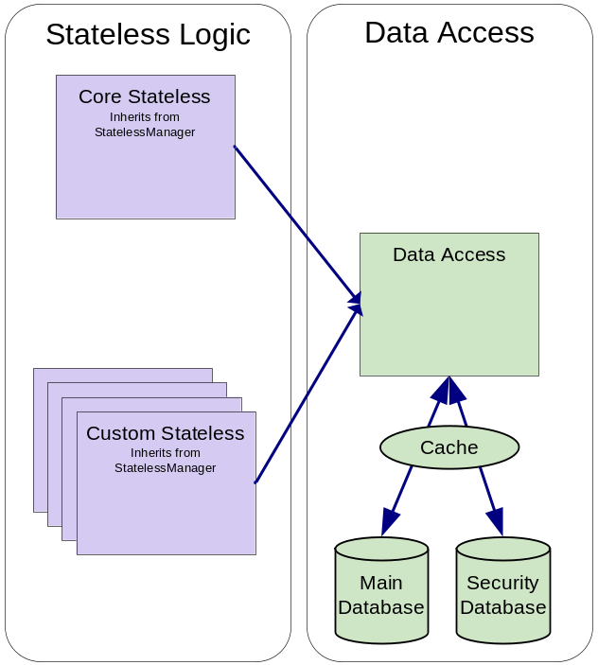

Figure 5.1a – The Data Access Tier

In certain instances it also maintains a cache to help minimise expensive data access. For example, querying a stored procedure’s parameters, if the stored procedure has already been examined before, its details will be in the cache and no database call will be made, helping reduce the load on limited resources.

The database Access Layer is based on Microsoft’s Database Access Application Block, but has been amended to include transaction handling and other required features. An overview of the database functions supplied by this block is shown below:

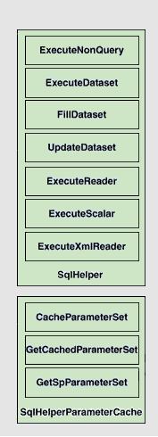

Figure 5.1b – The Microsoft Data Access Application Block

The credentials for the database access are supplied from the configuration file. This is either from the web configuration file, or the application frame configuration file.

The credentials are automatically encrypted in these files so people cannot access them directly. The usernames and password therefore can be controlled either on the web server or the client and the user’s organisation can determine the user access pattern they want to adopt for database access. This would normally be one of the following, or a mixture.

- Each user has their own credentials (Increased attack surface for hacking, increased maintenance, increased automatic auditing)
- Each role or group has their own credentials
- One or two database accounts are used for all database access (Reduced attack surface, reduced maintenance, reduced automatic auditing)

The Main Database

The main database holds the application level data. There may be more than one main Database depending on the number of applications the user is supporting.

The Security Database

The security database will hold all the user, groups and access rights information. It will also hold information relevant to the configuration of the application and its forms.

Shared Services
Shared services provide service s across some or all layers of the framework model. This ensures a common method of operation is enforced.

Communication
In order that all the layers understand what is being communicated, especially when we are using a far model of operation, shared communication libraries are used to provide interfaces and data types to standardise this operation.

The following are therefore exposed in the communication libraries:

- Service Interfaces

These describe the services provided by the stateless logic layer. To ensure consistency, the service interfaces are implemented on both the presentation and the business logic layer. An example of a service interface would be “Get Client” or “Update Client”.

Services are grouped logically, this means that client services are grouped under their own service interface, and fact find updates are grouped under another.

- Service Communication

This represents the base information for providing communication in the presentation tier. It uses the services interfaces to provide high level abstract classes that are used to control communication to the business logic tier.

Each service interface published will have its own unique Service Communication class to handle the service interface.

- Entity Interfaces

This represents the data that entities such as “Client” expose to the presentation tier. The interfaces define a fixed way of interacting with the entities.

The entity interfaces are as wrappers around the entity data and ensure that any access to the entity data is done in a controlled and uniform way.

- Entity Data

The entity data is represented as typed datasets. This is the core currency of data communication across the layers and tiers.

Communication across the presentation/Business Logic boundary is standardised using the above interfaces. A high level static structure diagram that represent how these different classes interact with each other can be shown below. The presentation classes are on the left and highlighted in yellow, while the business logic classes are on the right and highlighted in Mauve. The shared components are on the bottom and highlighted in grey,

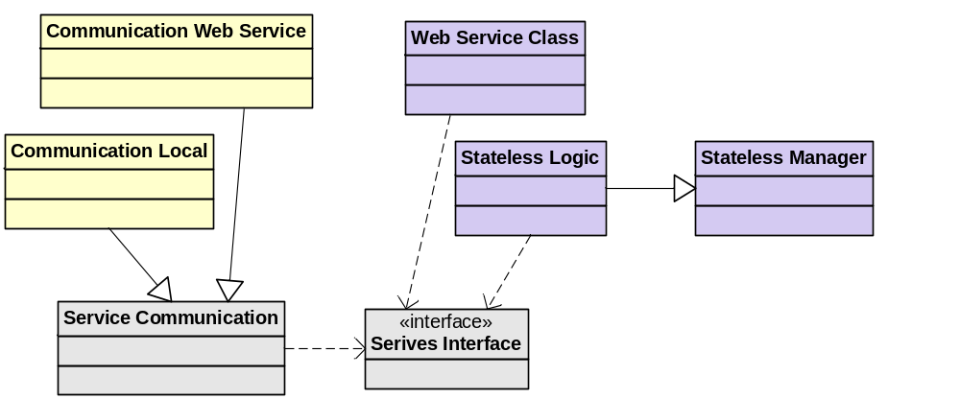

Figure 6.1a – Communication Static Structure Diagram

The sharing of the same interface defining the services exposed by the business layer ensures consistency when the framework is built and deployed.

Exception Management
Exception management is a shared process across all tiers to ensure all exceptions are centrally controlled. The exception management classes are based on Microsoft’s Exception Management Application block, but have been modified for use in the Application Framework.

The main elements of the exception management function can be shown below:

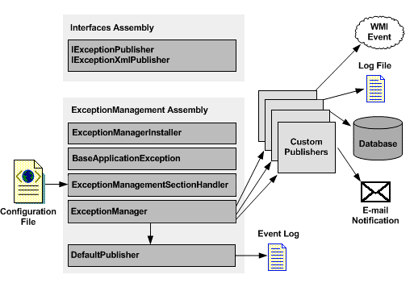
Figure 6.1b – The Microsoft Exception Application Block

When an exception occurs, and the exception management function is invoked, it handles the exception based on information contained in the application or web configuration file. The exception can then be published to one or more configured publishers.

Exceptions can currently be published to one or more of the following:

- Event Log
- Textual Log File
- Database Table
- Email
- Web Service

If an exception is published to 1st Services from an application, either via email or by a web services, there is an option to enter more details about the error. It is up to the user to enter more information about how the error occurred and they should be encouraged to do this in order to aid defect repair.

System Resources
Certain resources need to be shared across tiers. This would include common data types such as common enumerations. This library is used to share this information.

Common Utilities
This a core library of reusable algorithms can classes that are common between all tiers and as such have been extracted into a common library. Again this ensures consistency in that all tiers are using the same common utilities, and centralizes access to common functions.

Physical Design

Solution Deployment Models
This chapter concentrates on how the Generic Application Framework can be logically deployed based on solution requirements. The following sections do not go into detail about infrastructure or security apparatus outside the concern of the architecture, such as firewalls, but how the logical architecture can be translated to a physical environment.

Stand Alone
The standalone model involves all tiers being situated on a single machine. This can be shown in the diagram below. No other clients have access to the data and the business tier sits alongside the presentation tier.

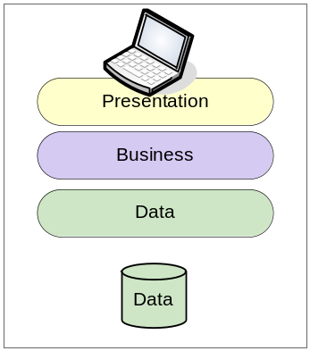

Figure 7.1a – Standalone Deployment Model

The standalone model will usually encompass MSDE as the database engine.

Remote Database
The remote database model is most commonly used in a LAN environment where several client machines are required to share data amongst themselves. Here are separate database server is used to host the database and the clients are configured to point to the remote server location.
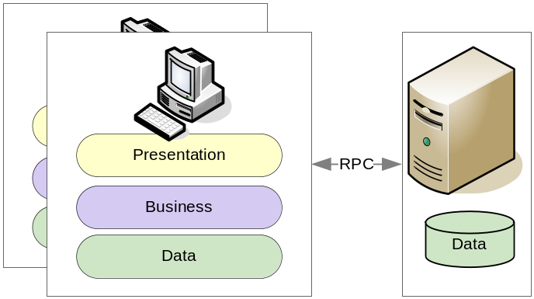

Figure 7.1b – Remote Database Deployment Model

The remote database solution usually encompasses SQL Server as the remote database solution. The transport mechanism will be RPC.

Remote Business Tier
This solution places the business logic tiers on a web server that can then be accessed using web services.

The remote business tier solution could be used over a LAN environment, but the additional work and traffic of having to make SOAP calls through a web server would seem to be unnecessary.

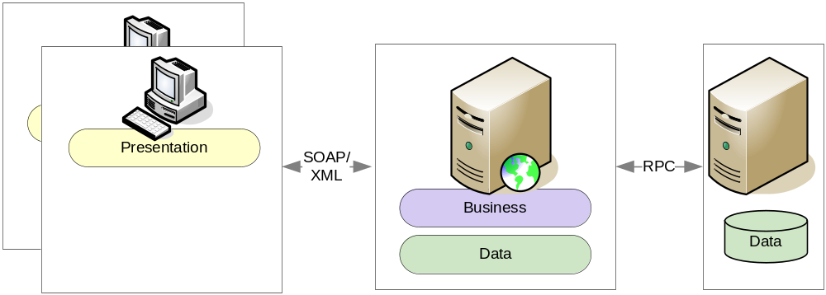

Figure 7.1c – Remote Business Logic Deployment Model

This solution is probably more likely to occur in a WAN or intranet environment, where clients can be geographically remote.

This deployment solution might also require additional physical architecture depending on the specific solution being catered for. Variables such as security, loading, bandwidth would all have to be taken into account. Additional web servers could be introduced to cater for load balancing and fault tolerance for example.

Mixed Architecture
In the real world several different physical architectures could be used for enterprise solutions.

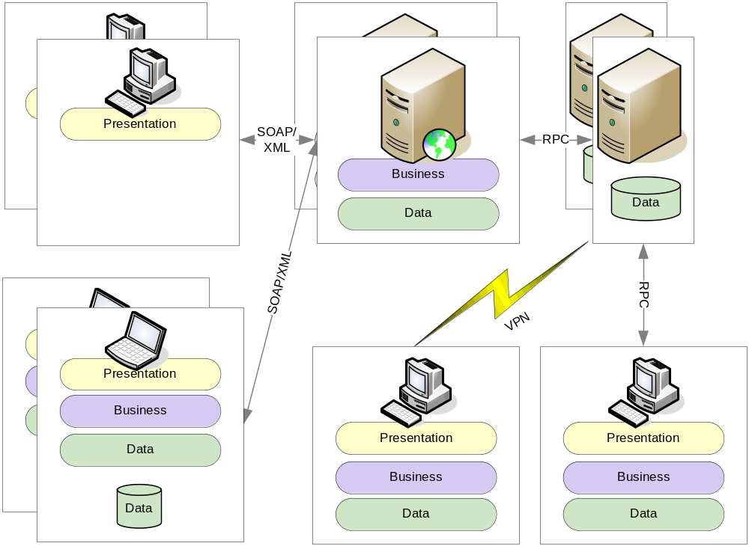

Figure 7.1d – Mixed Deployment Model

In this solution there are remote clients and local clients, accessing the same database servers. Clients can could also have full standalone solutions and be able to submit changes to the main database. In the mortgage centre application this is achieved through case submission, where completed packets of work are sent to the Mortgage Centre via the message centre module.

External Services

Adviser Evolution is designed to interact with other products and systems in a number of ways:

- Other Adviser Evolution systems using Database Replication
- Adviser Office, using XML based messages.
- Third party systems, using XML based messages.
- Third party products providing common information to Adviser Evolution (e.g. Postcode lookup)

Replication

Any number of Adviser Evolution users can share a common set of data. This is achieved by establishing a ‘Master’ database containing the complete set of data for an installation. Any number of Adviser Evolution clients can then be created, each using a subset of this data (usually based on ownership – i.e. an Adviser’s clients). This has two benefits in that not only is the system overhead of maintaining the data reduced by only processing a subset, but also security is enhanced by restricting access to data on a needs basis.

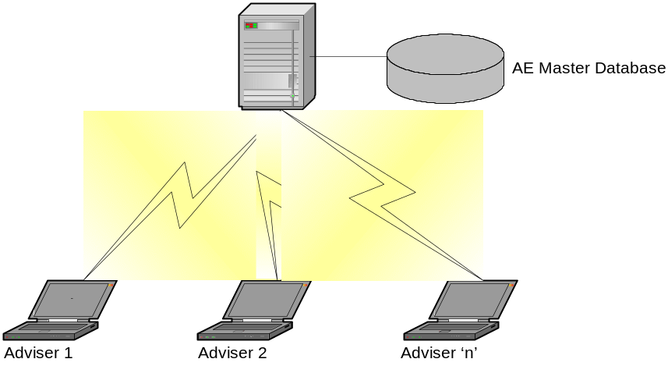

Adviser Office

Adviser Evolution can interact with an Adviser Office installation and maintain the contents of the two databases using a synchronisation process. Changes made in Adviser Evolution are propagated to Adviser Office, and vice versa. In this way an installation can (for instance) use Adviser Evolution for the Advisers, whilst maintaining an existing investment in Adviser Office for Back Office support.

The process is achieved by using XML messages which are created as a result of a change on one system (using database triggers). These are then sent to the ‘other’ system and processed into their database. In a multi-user installation, this synchronisation would take place with the ‘Master’ Adviser Evolution database described above. In this way, replication can be added to the solution to propagate the Adviser Office changes out to all Advisers.

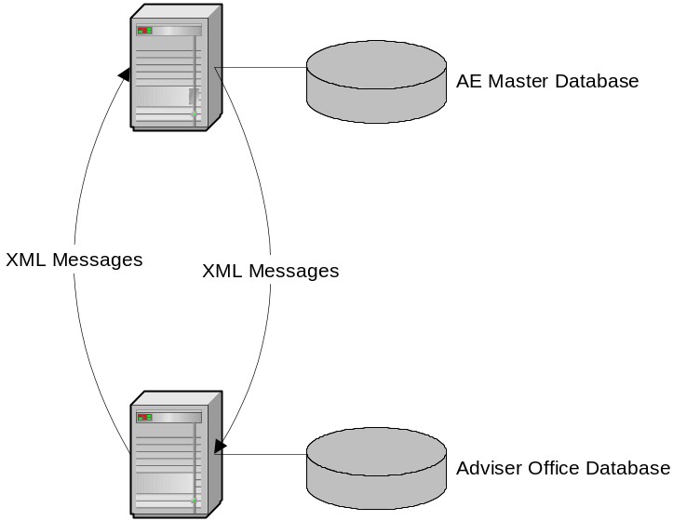

Third Party Systems using XML Messages

This is a generalised implementation of the infrastructure used to achieve the Adviser Evolution/Adviser Office integration. The concepts are identical and there are many common pieces of software involved.

The requirements of a third party system are met by implementing handlers for that system using pre-defined interfaces used by the infrastructure. In this way, the generic nature of the components is maintained whilst still allowing customisation.

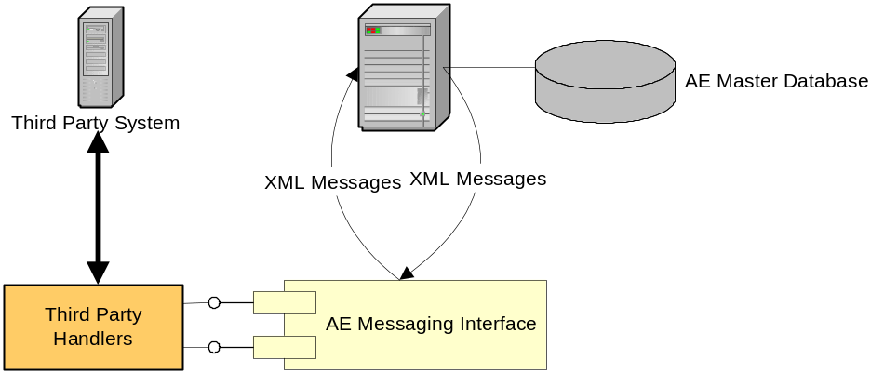

Third Party Products

Adviser Evolution can interact with third party products to provide data services for common functions. Currently this is implemented for:

- Postcode lookup
- Bank sort code and account number verification

Adviser Evolution implements an internal Broker Service to handle third party integrations. The Service Broker acts an abstracted interface between the Adviser Evolution and the TPP. This ensures only one internal interface is needed to support several external TPP interfaces. An example of this is a Postcode lookup that can be called using a Web Services in a network connected installation, or locally called when disconnected. The interface is also configured for different TPP’s such as QAS or Hopewiser.

When such services are not configured, Adviser evolution restricts the function so that interaction with them is not possible.

Additional handlers can be written at any time to extend the library of such services.

The following diagram illustrates the internal architecture.

